*****U*NIVERSITY OF *I*NFORMATION *T*ECHNOLOGY & *S*CIENCES (*UITS* )**

**ASSIGNMENT**

**on**

**INTERNET OF THINGS LAB**

⮘**Submitted To**⮚

***Ayanava Paul***

Lecturer,

Department of CSE, UITS

⮘**Submitted By**⮚

***F*AZLAY *R*ABBI**

* Department 🢣 CSE
* ID 🢣 2125051070
* Semester 🢣 Autumn 2024
* Batch 🢣 50
* Section 🢣 7B1
* Subject Code 🢣 CSE 402
* Date of Submission 🢣 10.11.2025

**Signature**

**Temperature and Ultrasonic Sensor**

**Title:** Take input from ultrasonic sensor and temperature sensor. Show the distance in cm and temperature in celsius in LCD. Also show the distance and temperature in serial monitor.

# Necessary Equipment:

1. Arduino UNO R3
2. Breadboard
3. 330 Ohm resistor
4. 3 LED
5. Ultrasonic distance sensor
6. LCD

# Objectives:

1. Temperature >= 75 degree celsius and Distance>=175 cm, Turn on RED LED only.
2. Temperature >= 50 and <75 and Distance >=150 cm and <175 cm, Turn on YELLOW LED only.
3. Temperature <50 and Distance<150 cm, Turn on GREEN LED only.

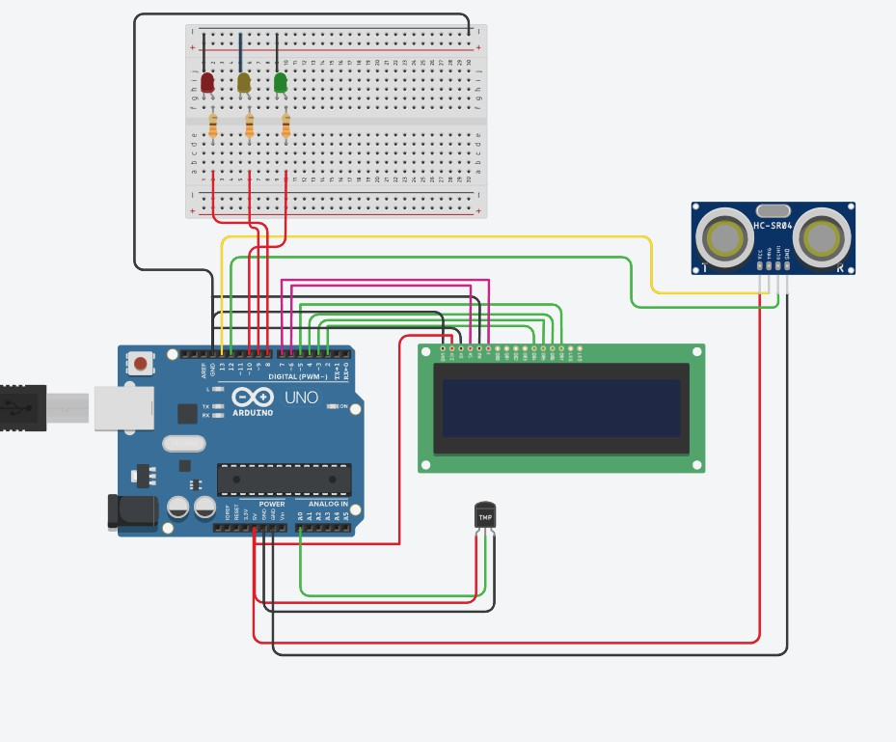

**Code:**

#include <LiquidCrystal.h> char temp[] ="Temprature_c:"; char dist[] = "Distance: ";

int trigPin=13; int echoPin=12;

int ledPin[] = {8,9,10}; int pinCount = 3;

LiquidCrystal lcd(6,7,2,3,4,5); // Rs, E, D4, D5 D6, D7

void setup()

{

pinMode(A0,INPUT);

pinMode(trigPin, OUTPUT); pinMode(echoPin, INPUT);

for(int i=0;i<pinCount;i++){ pinMode(ledPin[i], OUTPUT);

}

lcd.begin(16,2); Serial.begin(9600); delay(1000);

}

void loop()

{

int sensorValue = analogRead(A0); float mV=(sensorValue/1023.0)*5000; int tempCel=mV/10; Serial.println(tempCel);

digitalWrite(trigPin, LOW); delayMicroseconds(2); digitalWrite(trigPin, HIGH); delayMicroseconds(10); digitalWrite(trigPin, LOW);

long duration = pulseIn(echoPin, HIGH); float distance = (0.0332*duration)/2;

if(tempCel >= 75 && distance >= 175){ digitalWrite(ledPin[0], HIGH); delay(500);

digitalWrite(ledPin[0], LOW);

}else if(tempCel >= 50 && distance >= 150){

digitalWrite(ledPin[1], HIGH); delay(500); digitalWrite(ledPin[1], LOW);

}else{

digitalWrite(ledPin[2], HIGH); delay(500); digitalWrite(ledPin[2], LOW);

}

lcd.setCursor(0,0); lcd.print(temp);

lcd.setCursor(13,0); lcd.print(tempCel);

Serial.println(temp); lcd.setCursor(0,1); lcd.print(dist);

lcd.setCursor(9,1); lcd.print(distance);

Serial.println(distance); delay(1000);

}